New Women Ski Snow Hiking Climb Travel Waterproof Thick Warm Long Pants Trousers
Condition:- Brand New

Size: Please compare it to your body clearly,
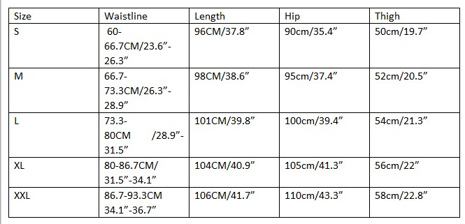
- Pant only,
1inch=2.54cm
Package only include 1 pcs , other accessories or clothes are not include.
Maybe there is 0.8-1.2inch error.It is measured by manual.

